
Astana IT University

Introduction to Threat Hunting

week 8

Creating a Plan to Emulate an Attacker's Action

Students:
Aruzhan Abdulina, Kanasheva Darina

Instructor:

Tendikov Noyan

Submission Date: 29.10.2026
Adversary emulation plan is an attack plan written down in advance, before anything is actually executed. A red team asks “if we were a real adversary — in this case Storm-0501 — how exactly would we attack this network, step by step?” The plan usually follows the Kill Chain structure: Initial Access >Lateral Movement > Execution > Persistence > Exfiltration. The point is not simply to “hack” something, but to check whether the defensive controls and SIEM detections actually fire at each step which is why every step is tied to a specific MITRE ATT&CK technique.
This week differs from Weeks 4-7: there we analyzed and detected activity that had already happened; here the chain of attack has to be designed in writing first — from initial access to persistence and exfiltration with each step mapped to a concrete ATT&CK technique, and only then executed. The plan is built on the Storm-0501 threat profile studied in Week 4 (Microsoft Threat Intelligence reports MS-2024 and MS-2025).

Emulation Plan
Phase | Attacker action | Tool / command | MITRE ATT&CK technique | Expected log artifact
1. Initial Access | Gaining access to the host using valid (assumed compromised) local administrator credentials. | evil-winrm -i 192.168.0.6 -u Administrator -p 'Pass123_A' | T1078 — Valid Accounts | Windows Security Log, Event ID 4624, Logon Type 3 (network logon)
2. Lateral Movement | Establishing a remote WinRM session from the attacker machine to the target host. | evil-winrm -i 192.168.0.6 -u Administrator -p 'Pass123_A' | T1021.006 — Remote Services: WinRM | Sysmon EventCode 3 (network connection to port 5985); Sysmon EventCode 1 (wsmprovhost.exe process)
3. Execution & Discovery | Running reconnaissance commands inside the session: checking user context, accounts, network configuration, and security-service status. | whoami · net user · ipconfig /all · sc query sense · sc query windefend | T1033, T1087.001, T1016, T1518.001 | Sysmon EventCode 1 — child processes with ParentImage = wsmprovhost.exe
4. Persistence (planned) | Establishing persistence by creating a scheduled task that runs as SYSTEM. | schtasks /create /tn "WindowsUpdateCheck" /tr "powershell.exe -command whoami" /sc daily /st 09:00 /ru SYSTEM | T1053.005 — Scheduled Task | Windows Security Log / Task Scheduler log, task-creation event
5. Collection & Exfiltration (planned) | Collecting files from user directories, archiving them, and transferring the archive back to the attacker machine. | Get-ChildItem ... | Out-File; Compress-Archive ...; download <file> (Evil-WinRM command) | T1005, T1560.001, T1048 | Network connections with an abnormal volume of outbound traffic to the attacker's IP

Plan Execution

Phase 1 — Initial Access

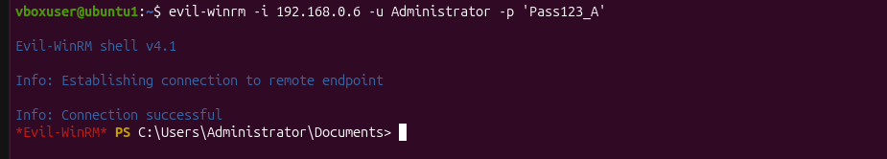
Successful Evil-WinRM (v4.1) session established on host 192.168.0.6 as Administrator.
To validate Phase 1 activities independently from service-level execution logs, targeted telemetry queries were executed against the Windows Security Log (EventCode=4624 - Successful Logon) within Splunk SIEM.
As illustrated in the evidence above, 206 network logon events (Logon_Type=3) were logged across the test window. The telemetry confirms repeated remote authentication attempts originating from the attacker node (192.168.0.4) targeting the local Administrator account via NTLM authentication. These findings confirm the successful execution and detection of technique T1078 (Valid Accounts), officially moving Phase 1 validation status from Unverified to Verified.

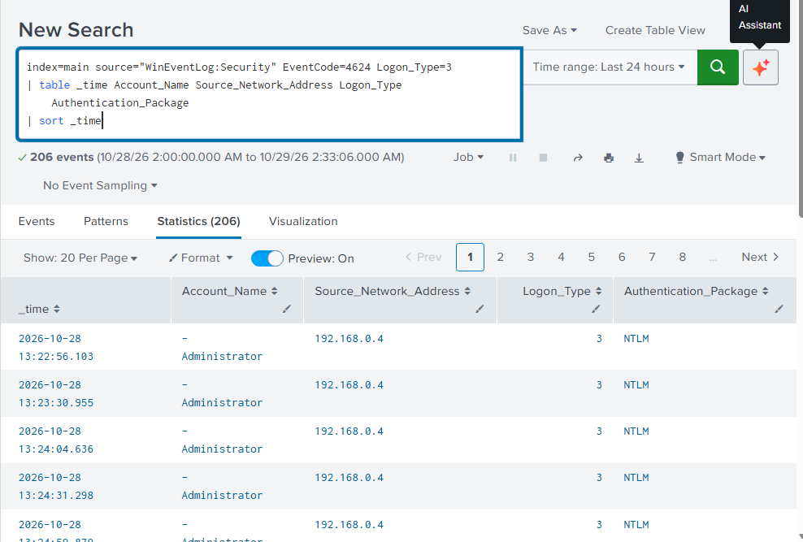

Phase 2 — Lateral Movement
A remote WinRM session was established from the attacker's Ubuntu machine to the target Windows host using valid local administrator credentials.
Fig. 1. Successful Evil-WinRM (v4.1) session established on host 192.168.0.6 as Administrator.
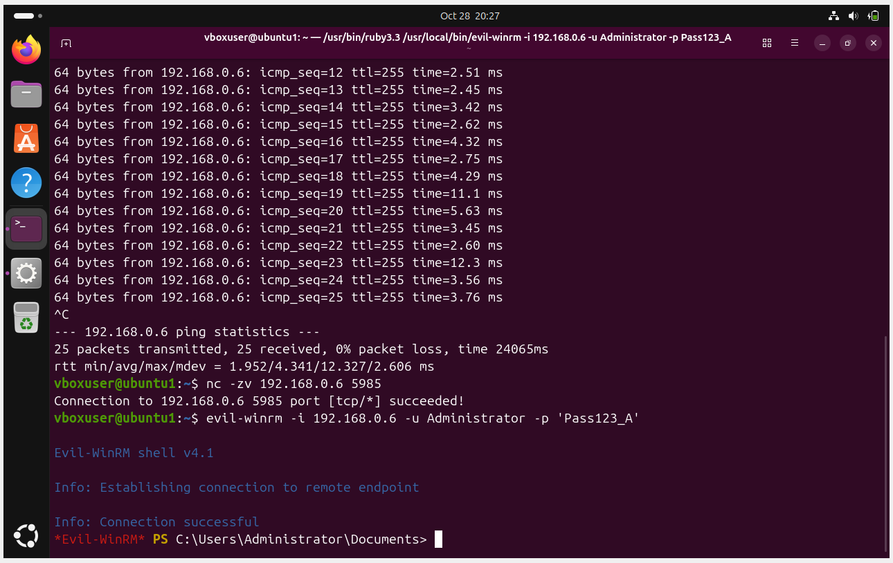
Fig. 2. Full pre-connection check: ICMP reachability of the host (25/25 packets), verification of open port 5985 via netcat, and a successful Evil-WinRM connection.

Phase 3 — Execution & Discovery
A series of reconnaissance commands, typical of Storm-0501's post-exploitation behavior, was run inside the session: checking the privilege context, local user accounts, network configuration, and the status of Windows security services.
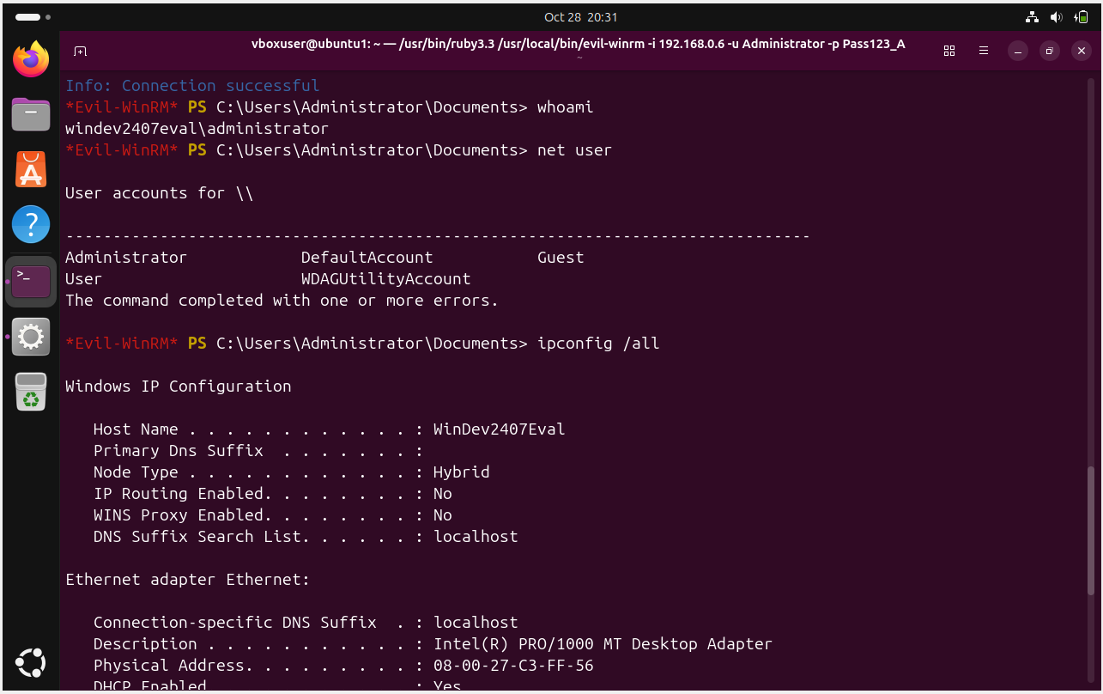
Fig. 3. whoami confirms the windev2407eval\administrator context, net user lists local accounts, and ipconfig /all begins.
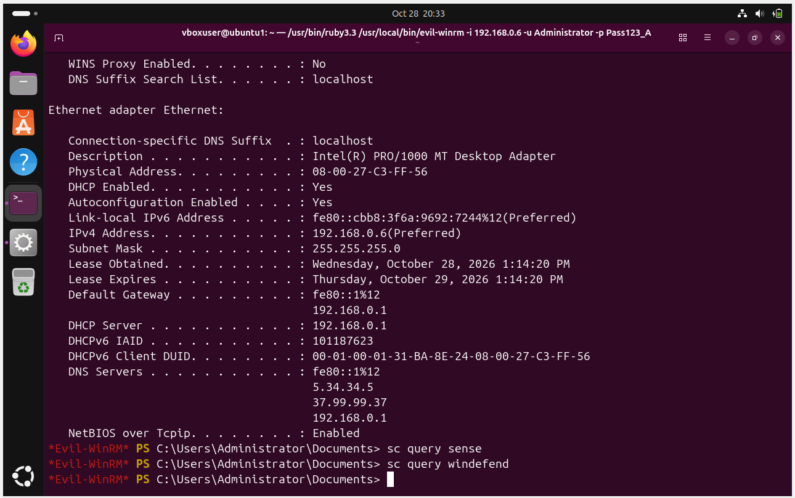
Fig. 4. Continuation of ipconfig /all output (IP address 192.168.0.6, DHCP, DNS) followed by sc query sense / sc query windefend — checking the status of Microsoft Defender and Defender for Endpoint.
Splunk Validation
To confirm that the executed actions are recorded in telemetry and trigger the detection built in Week 7 (the CAR-2014-11-004 analytic), a series of SPL queries was run.

5.1 Network connections to the WinRM port (Sysmon EventCode 3)
SPL query:
index=main source="WinEventLog:Microsoft-Windows-Sysmon/Operational" EventCode=3 DestinationPort=5985 | table _time SourceIp DestinationIp DestinationPort Image ProcessId | sort _time
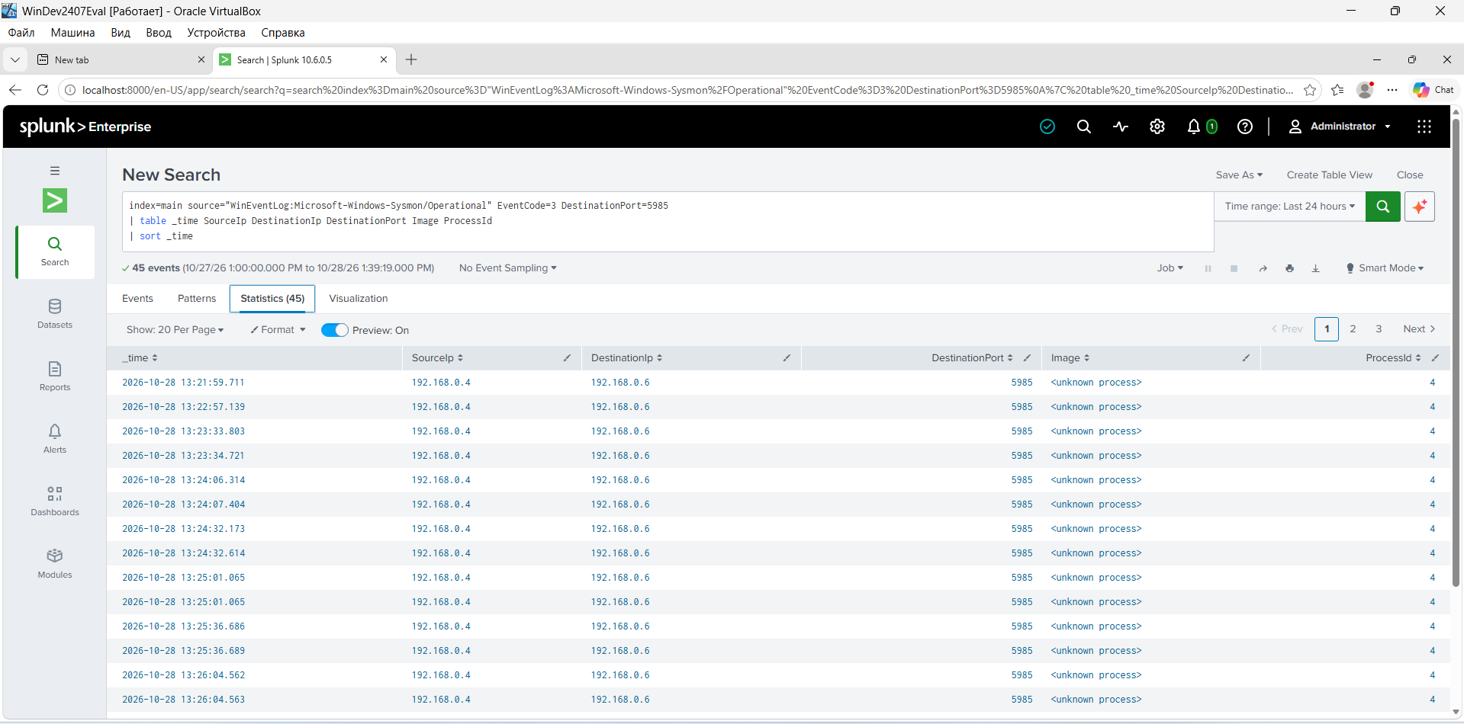
Fig. 5. 45 network-connection events found from the attacker's IP (192.168.0.4) to port 5985 on the target host (192.168.0.6).

5.2 Creation of the wsmprovhost.exe process (Sysmon EventCode 1)
index=main source="WinEventLog:Microsoft-Windows-Sysmon/Operational" EventCode=1 Image="*\\wsmprovhost.exe" | table _time host Image ProcessId ParentProcessId CommandLine | sort _time
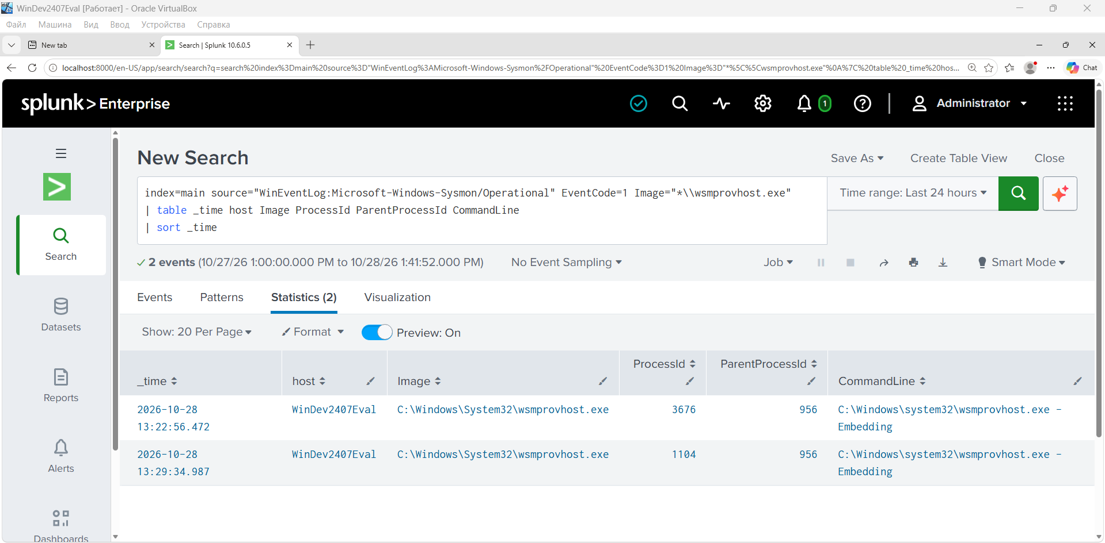
Fig. 6. Two wsmprovhost.exe creation events found (parent process svchost.exe, ParentProcessId 956); the command line contains the -Embedding flag, typical of a WinRM session host process.

5.3 Child reconnaissance commands (ParentImage = wsmprovhost.exe)
index=main source="WinEventLog:Microsoft-Windows-Sysmon/Operational" EventCode=1 ParentImage="*\\wsmprovhost.exe" | table _time User ParentImage Image CommandLine | sort _time
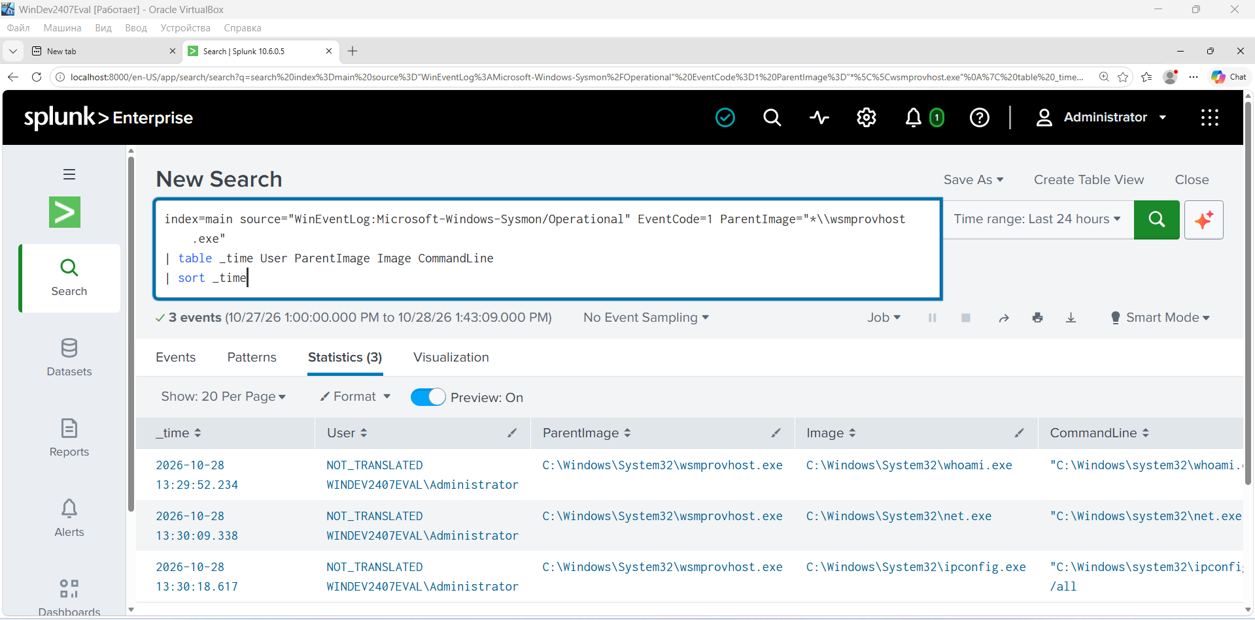
Fig. 7. Three child processes (whoami.exe, net.exe, ipconfig.exe) with ParentImage = wsmprovhost.exe and user context WINDEV2407EVAL\Administrator — direct evidence that the Phase 3 commands were executed through the remote WinRM session, not locally.

5.4 Validating the CAR-2014-11-004 analytic
index=main source="WinEventLog:Microsoft-Windows-Sysmon/Operational" EventCode=1 Image="*\\wsmprovhost.exe" | table _time ParentImage Image CommandLine
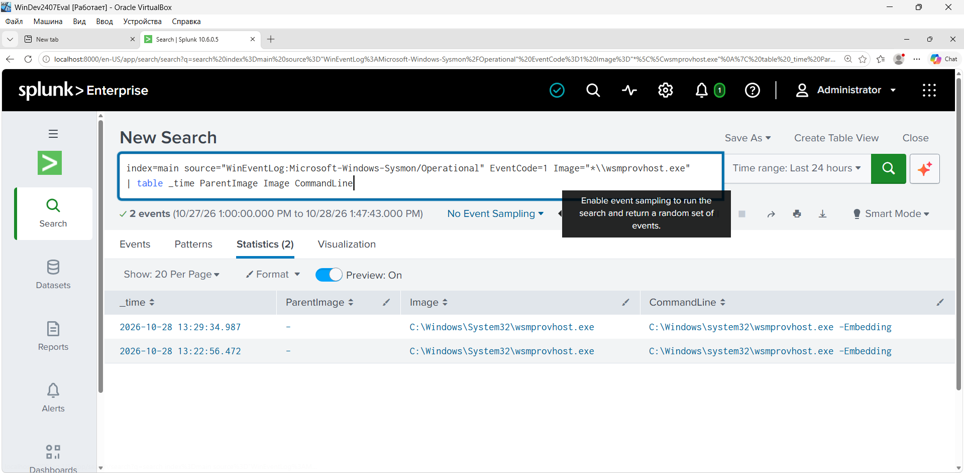
Fig. 8. A repeat query matching the CAR-2014-11-004 analytic condition (wsmprovhost.exe process) — 2 events, consistent with what should have triggered the scheduled alert built in Week 7.

5.5 Confirming Phase 1 — Initial Access (T1078)
Phase 1 and Phase 2 of this lab are two sides of the same event: authenticating with valid Administrator credentials directly results in the WinRM session being established. To obtain an independent artifact for T1078, Windows Security Log collection (Event ID 4624) was added to the Splunk configuration (it was not collected previously, only the Sysmon channel was). After enabling it and reconnecting via Evil-WinRM, the following query was run:
index=main source="WinEventLog:Security" EventCode=4624 Logon_Type=3 | table _time Account_Name Source_Network_Address Logon_Type Authentication_Package | sort _time
Fig. 9. 206 matching logon events. Account_Name = Administrator, Source_Network_Address = 192.168.0.4 (the attacker's Ubuntu IP), Logon_Type = 3 (network logon — consistent with a WinRM/SMB-type connection, as opposed to Logon Type 2, an interactive console login), Authentication_Package = NTLM, confirming that authentication used NTLM rather than Kerberos, which is typical when connecting by IP address rather than a domain FQDN.
This result closes the gap left in earlier validation attempts and confirms Phase 1 (T1078) independently of Phase 2 (T1021.006): the Security log now shows the authentication event itself, while Sysmon shows the resulting WinRM session — together they form a complete, corroborated chain from valid-credential logon to remote command execution.

Validation Status by Plan Phase
Important note: not every phase of the original plan (Section 3) was actually executed in this lab session. The table below honestly reflects the status of each one.
Plan phase | Validation status in this lab | Basis
1. Initial Access (T1078) | Confirmed | Windows Security Log, Event ID 4624, Logon Type 3 — 206 matching events, Account_Name=Administrator, Source_Network_Address=192.168.0.4 (attacker's Ubuntu IP), Authentication_Package=NTLM
2. Lateral Movement (T1021.006) | Confirmed | Sysmon EventCode 3 — 45 network connections to port 5985; Sysmon EventCode 1 — 2 wsmprovhost.exe creation events
3. Execution & Discovery | Confirmed | Sysmon EventCode 1 — whoami.exe, net.exe, ipconfig.exe with ParentImage = wsmprovhost.exe
4. Persistence (T1053.005) | Not executed in this session | Planned, but not run or screenshotted
5. Exfiltration | Not executed in this session | Planned, but not run or screenshotted
Phases 4 (Persistence) and 5 (Exfiltration) remain part of the documented plan but were not run at the time this report was prepared — they are noted as further work rather than as a validated, completed result.

Conclusions
- The emulation plan is built directly on the documented Storm-0501 TTPs from Week 4 and is a logical continuation of the technical work started in Weeks 6–7.
- The Lateral Movement (T1021.006) and Execution & Discovery phases were executed and fully confirmed by Sysmon telemetry and Splunk queries, including the condition matching the CAR-2014-11-004 analytic.
- The Initial Access phase (T1078) is now also independently confirmed, after enabling Windows Security Log collection in Splunk — Event ID 4624, Logon Type 3, NTLM, source IP matching the attacker machine.
- The Persistence and Exfiltration phases remain planned but not executed — flagged as the next step.

